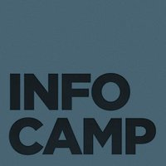
InfoCamp Seattle – Trip Report
  - October 2 & 3, 2010

Executive Summary
After having attended InfoCamp annually since it was founded in 2007, Michael suggested Donald might be interested in attending, since the focus is on collaboration, innovation, and building community across various information disciplines. Both attended Saturday, and Michael also attended on Sunday.
Donald presented Big History, Deep Zoom, Long Tail: Games for Learning, Digital Humanities, Digital Heritage. His session was very well received, particularly the Chronozoom portion, with “Zoom is the new search” becoming a controversial tagline that continued to be discussed for the rest of the conference. The session generated positive buzz around Microsoft Research and its projects.
Michael presented Understanding (Feynman), Or What I Learned in My First Month at Microsoft Research once on Saturday and after a request, again on Sunday. His session was also well received. After the conference, his slides were posted on Slideshare.
Donald and Michael also attended various sessions, and connected with attendees. Joe Janes from the UW iSchool held a brainstorming session on how to improve the iSchool experience which Michael attended, and this led to future collaboration opportunities between E&SC and the UW iSchool.

Attendees
Michael Adcock, Donald Brinkman

From InfoCamp Seattle Blog:
- 424 total attendees
- At least 43 programs from 18 schools were represented among the 146 student attendees.
- Participants traveled to InfoCamp from 2 Canadian provinces and 9 US states: BC, CA, ID, NJ, NY, Ontario, OR, TN, TX, VA, WA.
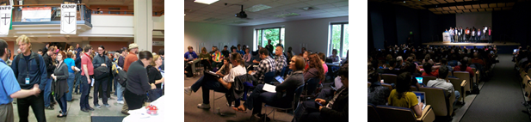

About InfoCamp
InfoCamp is an affordable, open unconference where people excited about information gather to collaborate, innovate, and build community.
InfoCamp attracts people from a variety of disciplines, such as information architecture, informatics, library & information science, taxonomy, interaction design, user experience, user-centered design, information design, online search, information management, informatics, technical communication, human-centered design and engineering, human-computer interaction, and more.
In attendance are professionals and practitioners from industry, academia, non-profits, government, libraries, and other sectors; people seeking work; hobbyists; and students.
From the InfoCamp Seattle Blog:
- 58 breakout sessions were proposed during the event and led by participants.
- Up to 9 breakout sessions ran simultaneously.
- 1,576 tweets related to InfoCamp were tweeted over the weekend.

Observations
The format of the conference encouraged discussion after each session, and allowed for new session proposals as the event took place. The mixture of students, researchers, and professionals provided an enthusiastic and interested audience for the sorts of solutions Microsoft Research focuses on, in particular the E&SC group. Sessions took many forms: group brainstorming discussions, a short presentation of an idea followed by discussion, and more standard presentation-style sessions.

Recommendations
Although we were too late to provide sponsorship this year, Donald and Michael agree that InfoCamp provides an environment for networking and collaboration, and attracts attendees who might be interested in or could positively contribute to Microsoft Research initiatives. Each year InfoCamp seeks two keynote speakers for the event (the only planned sessions), and this could be an opportunity for a Microsoft Research speaker as well.

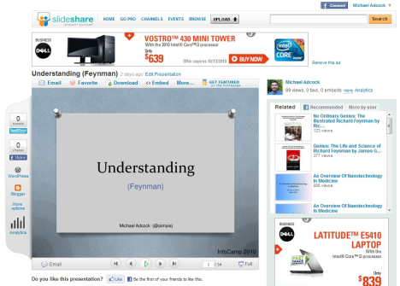
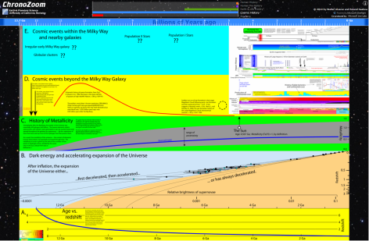
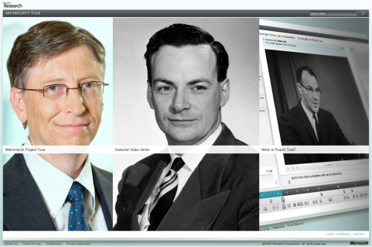
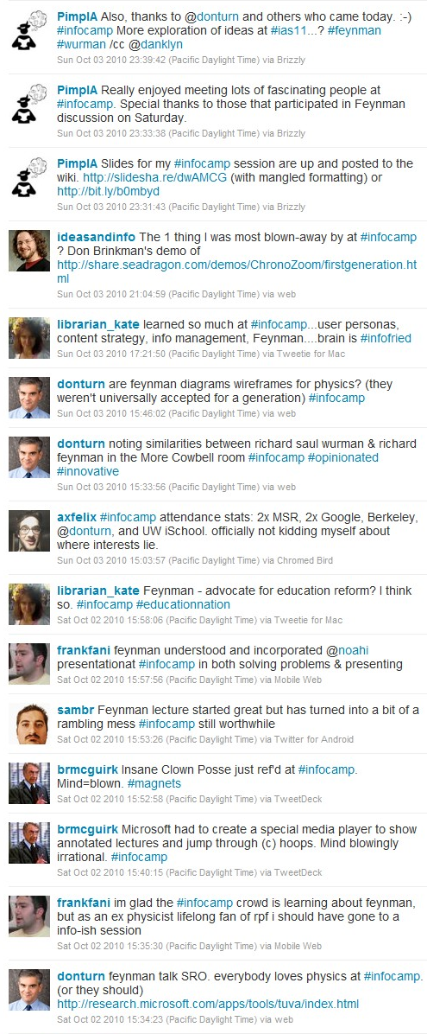
Tweet Timeline (reverse chronological order)
Understanding (Feynman), Or What I Learned in My First Month at Microsoft Research
Michael Adcock
From 3:00 – 3:45pm in “More Cowbell”
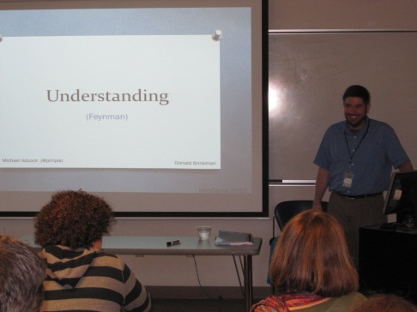
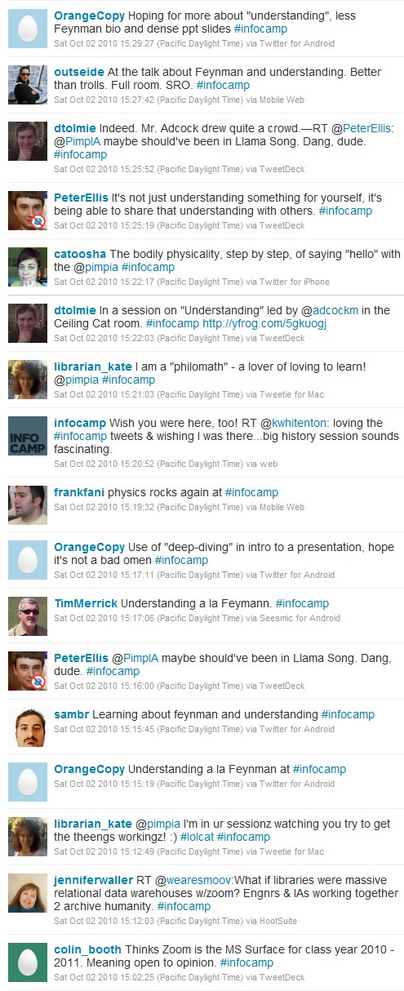
Understanding (Feynman), Or What I Learned in My First Month at Microsoft Research
Michael Adcock
From 3:15 – 4:00pm in “Ceiling Cat”
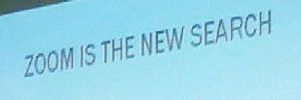
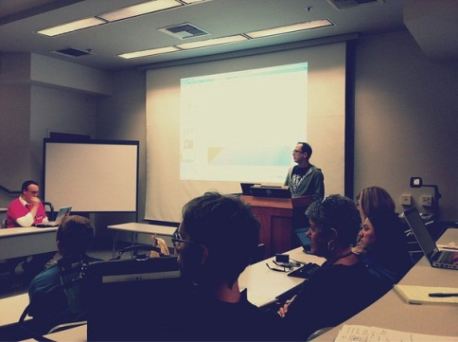
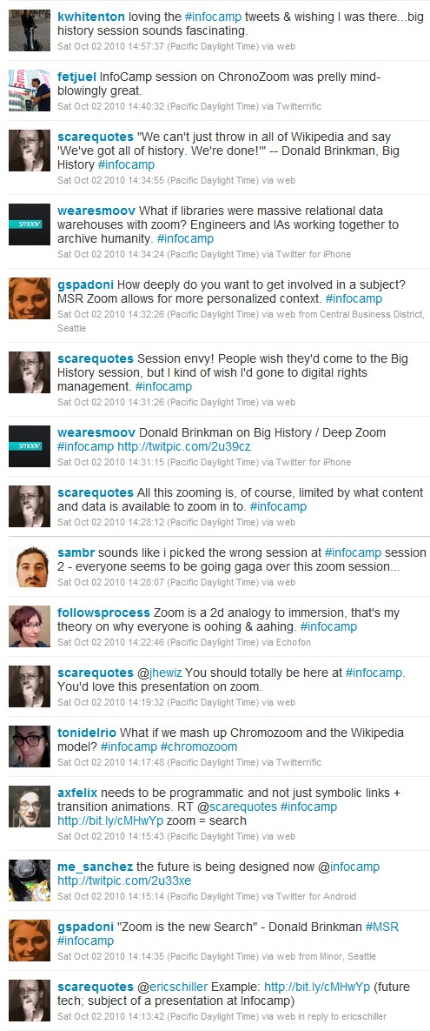
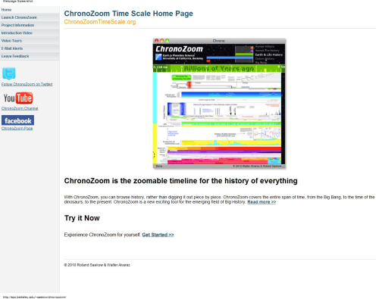
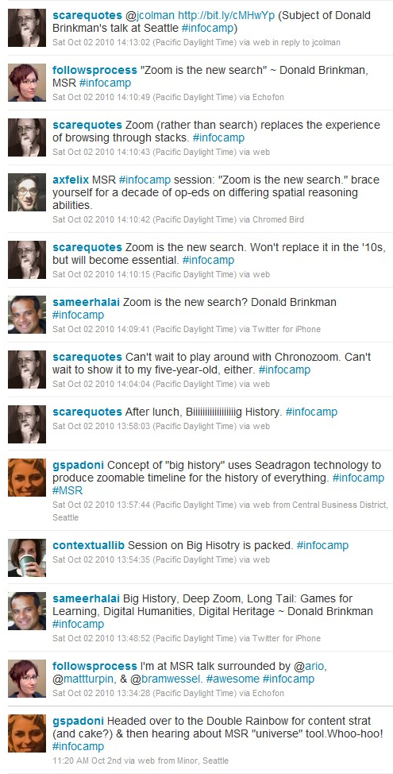
Big History, Deep Zoom, Long Tail: Games for Learning, Digital Humanities, Digital Heritage
Donald Brinkman
From 1:45 – 2:30pm in “Double Rainbow”

Assorted Photos
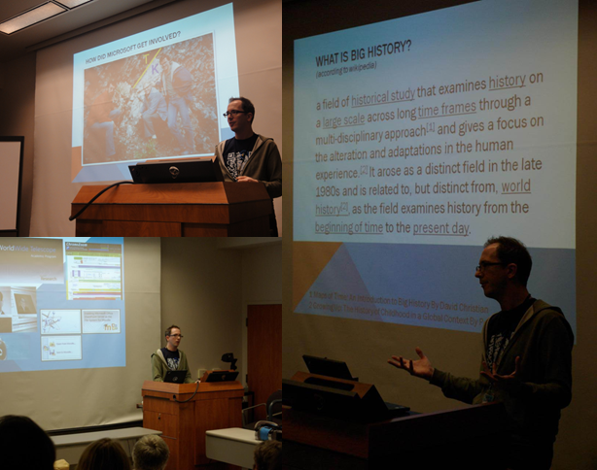

Donald’s Big History, Deep Zoom, Long Tail: Games for Learning, Digital Humanities, Digital Heritage
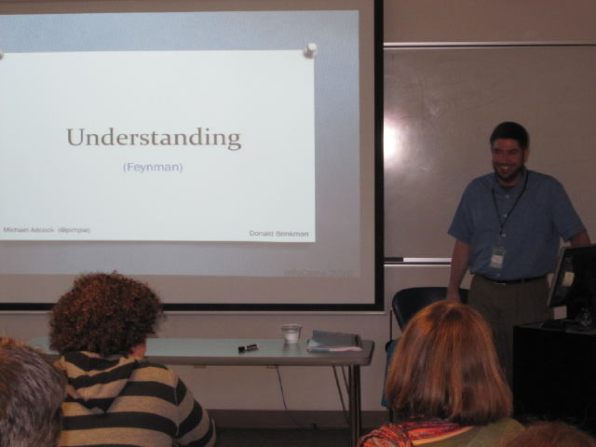

Michael’s Understanding (Feynman), Or What I Learned in My First Month at Microsoft Research

